[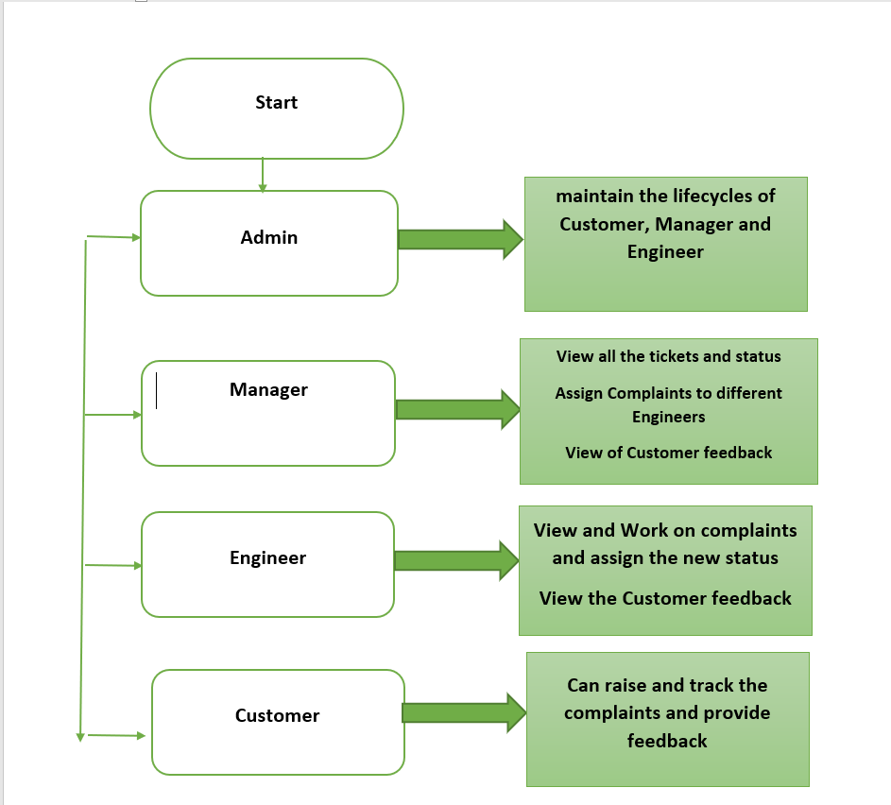](https://github.com/mcvrvikram/Complaint-Frontend/blob/master/src/assets/flowchart.PNG)